Pupil allergy policy

The Federation of Chislet Church of England and Hoath Primary Schools
A journey of learning for all,  within God’s guiding hands | 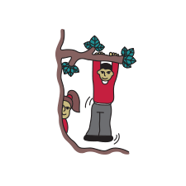  Hoath Primary School  Small school, big community. unlimited potential

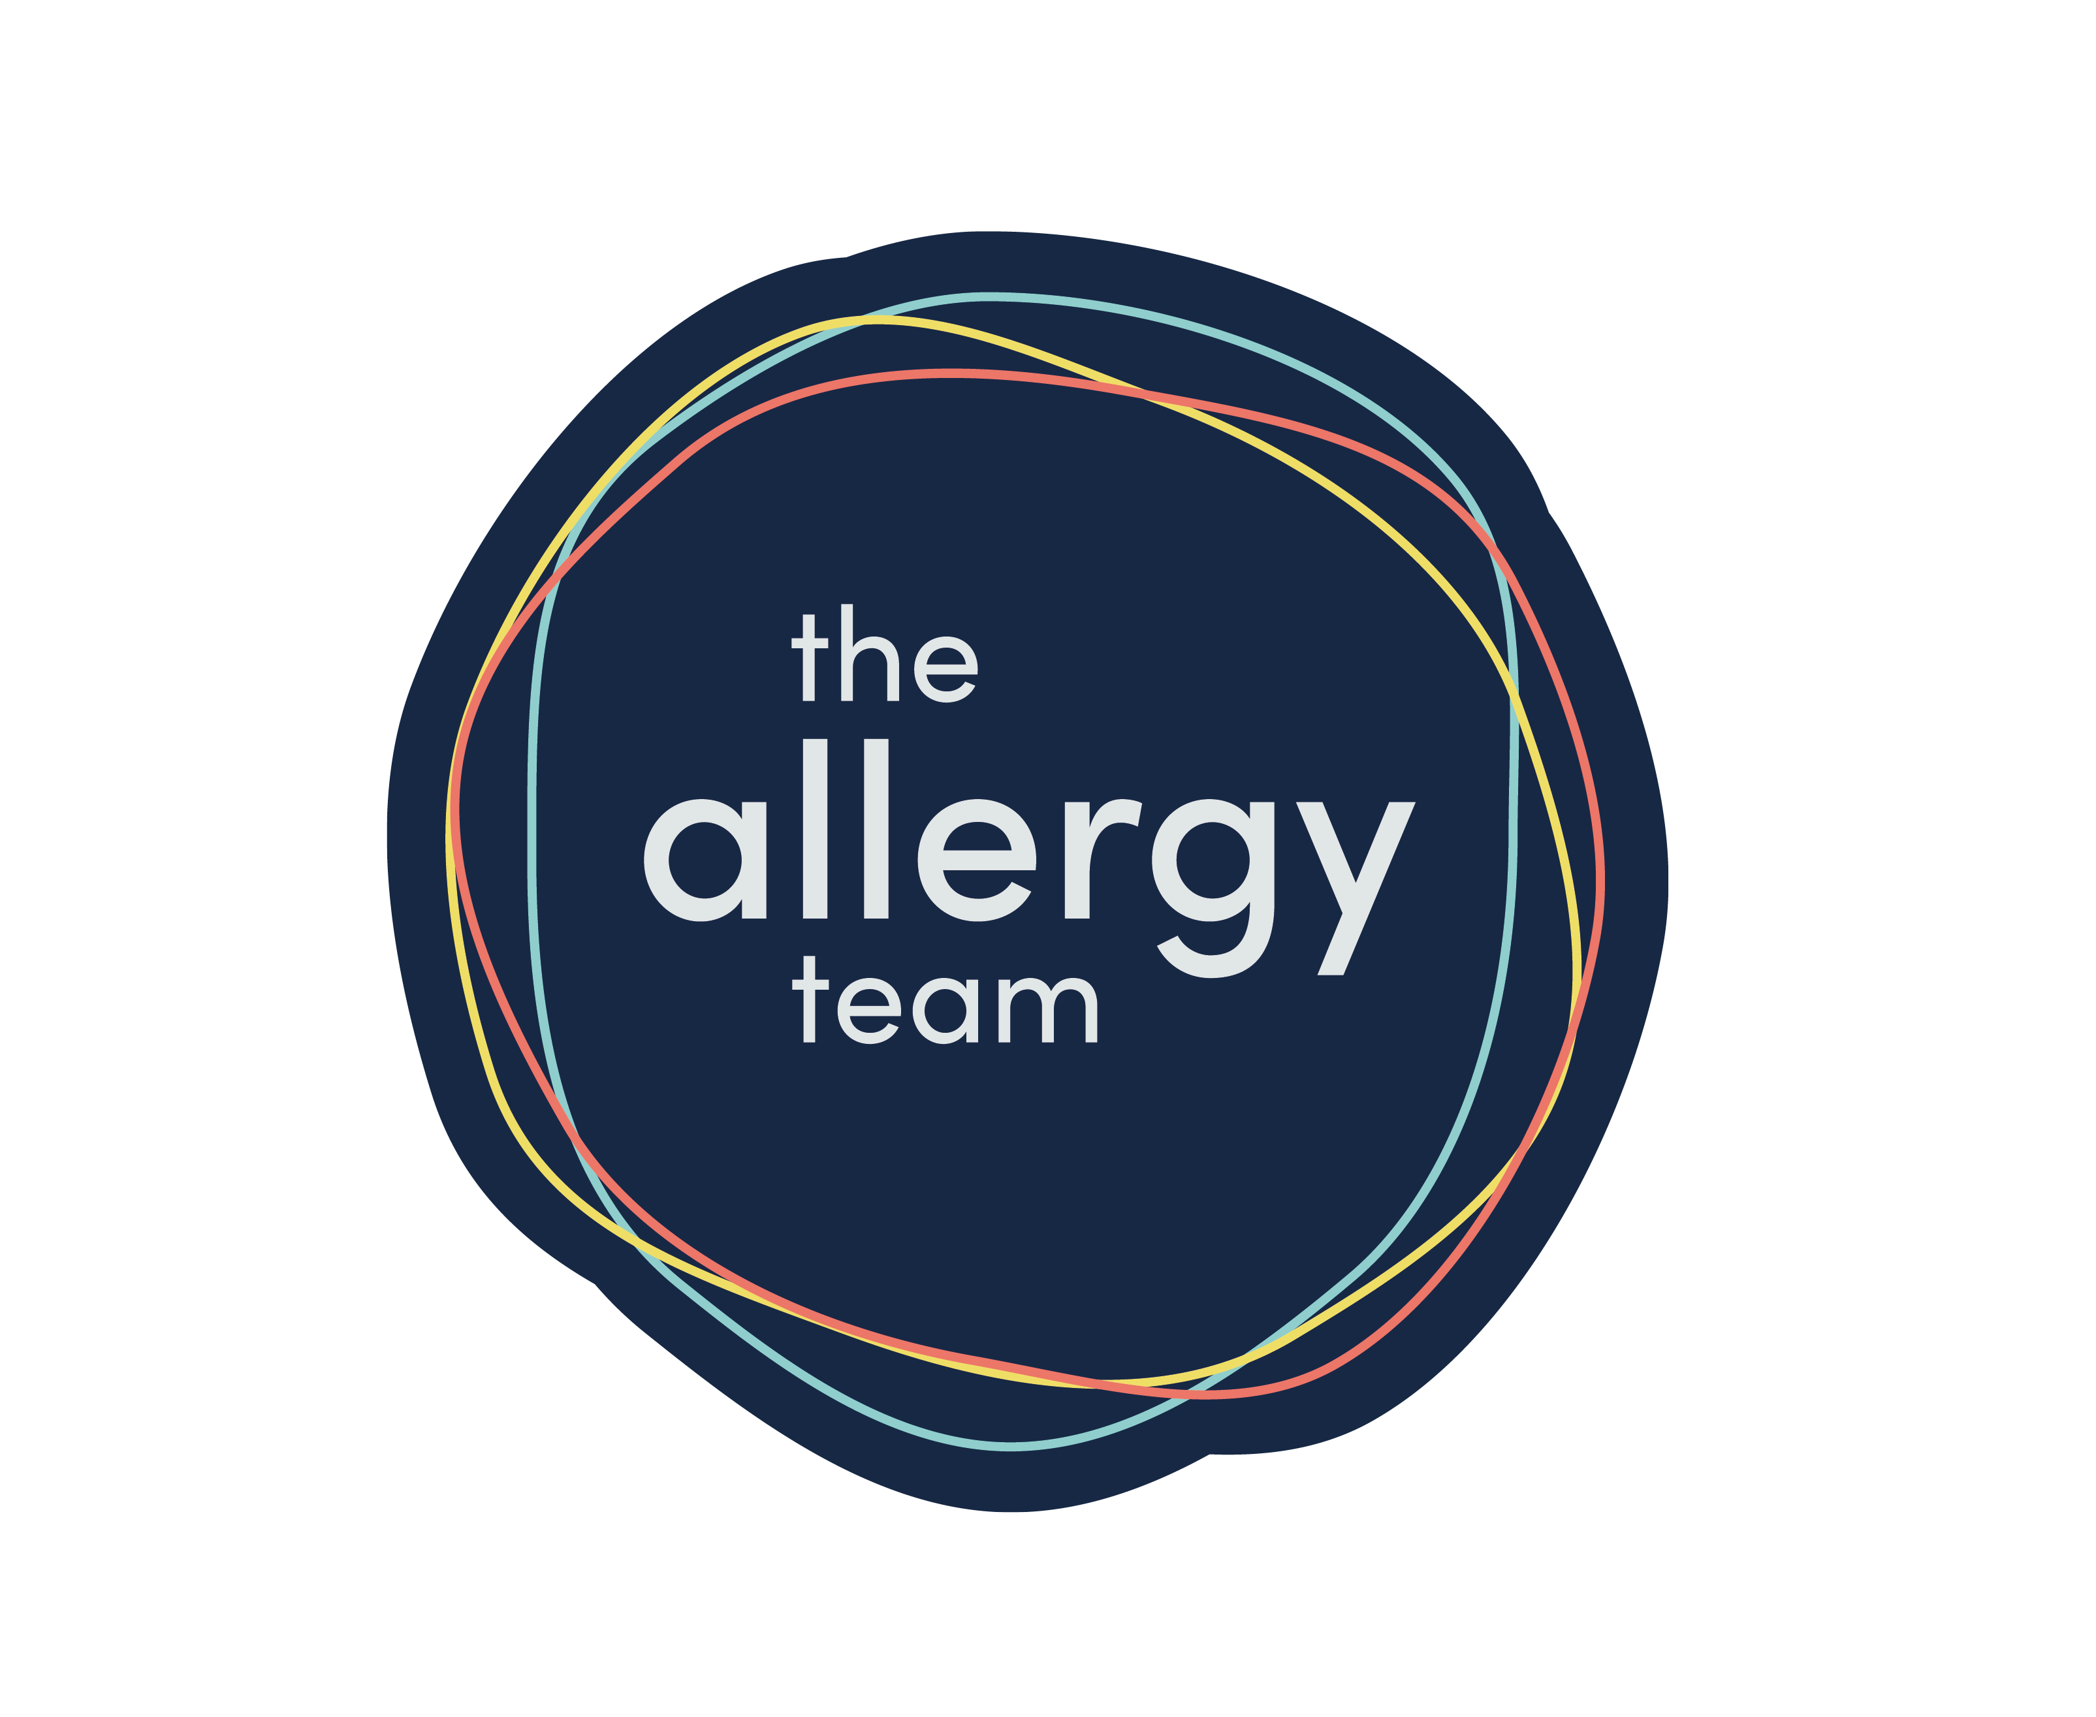

Approved by: | Full Governing Body | Date: 15/09/2026
Last reviewed on: | 15/09/2026
Next review due by: | September 2027

Contents
1. Aims 3
2. Legislation and guidance 3
3. Roles and responsibilities 3
4. Assessing risk 5
5. Managing risk 5
6. Procedures for handling an allergic reaction 7
7. Adrenaline auto-injectors (AAIs) 7
8. Training 9
9. Links to other policies 9

1. Aims
From this point the Federation of Chislet Church of England and Hoath Primary Schools will we known as school.
This policy aims to:
- Set out our school’s approach to allergy management, including reducing the risk of exposure and the procedures in place in case of allergic reaction
- Make clear how our school supports pupils with allergies to ensure their wellbeing and inclusion
- Promote and maintain allergy awareness among the school community

2. Legislation and guidance
This policy is based on the Department for Education (DfE)’s guidance on allergies in schools and supporting pupils with medical conditions at school, the Department of Health and Social Care’s guidance on using emergency adrenaline auto-injectors in schools, and the following legislation:
- The Food Information Regulations 2014
- The Food Information (Amendment) (England) Regulations 2019

3. Roles and responsibilities
We take a whole-school approach to allergy awareness.
3.1 Allergy lead
The nominated allergy lead is Anthony Sanders (Head of Shools, Lead DSL and Designated Teacher).
They are responsible for:
- Promoting and maintaining allergy awareness across our school community
- Ensuring the recording and collating allergy and special dietary information for all relevant pupils is updated and maintained.
- Ensuring:
- All allergy information is up to date and readily available to relevant members of staff
- All pupils with allergies have an allergy action plan completed by a medical professional
- All staff receive an appropriate level of allergy training
- All staff are aware of the school’s policy and procedures regarding allergies
- Relevant staff are aware of what activities need an allergy risk assessment
- Keeping stock of the school’s adrenaline auto-injectors (AAIs)
- Regularly reviewing and updating the allergy policy
3.2 Deputy Headteachers/Office managers
The office manager is responsible for:
- Co-ordinating the paperwork and information from families
- Co-ordinating medication with families
3.2a
The deputy Headteacher is responsible for:
- Maintaining medical records remain updated and added digitally to Teams and displayed in staff room.
- Ensuring relevant staff are informed of any allergies.
3.3 Teaching and support staff
All teaching and support staff are responsible for:
- Promoting and maintaining allergy awareness among pupils
- Maintaining awareness of our allergy policy and procedures
- Being able to recognise the signs of severe allergic reactions and anaphylaxis
- Attending appropriate allergy training as required
- Being aware of specific pupils with allergies in their care
- Carefully considering the use of food or other potential allergens in lesson and activity planning
- Ensuring the wellbeing and inclusion of pupils with allergies
3.4 Parents/carers
Parents/carers are responsible for:
- Being aware of our school’s allergy policy
- Providing the school with up-to-date details of their child’s medical needs, dietary requirements, and any history of allergies, reactions and anaphylaxis
- If required, providing their child with 2 in-date adrenaline auto-injectors and any other medication, including inhalers, antihistamine etc., and making sure these are replaced in a timely manner
- Carefully considering the food they provide to their child as packed lunches and snacks, and trying to limit the number of allergens included
- Following the school’s guidance on food brought in to be shared
- Updating the school on any changes to their child’s condition
3.5 Pupils with allergies
These pupils are responsible for:
- Being aware of their allergens and the risks they pose
- Understanding how and when to use their adrenaline auto-injector
- If age-appropriate, carrying their adrenaline auto-injector on their person and only using it for its intended purpose
3.6 Pupils without allergies
These pupils are responsible for:
- Being aware of allergens and the risk they pose to their peers

4. Assessing risk
The school will conduct a risk assessment for any pupil at risk of anaphylaxis taking part in:
- Lessons such as food technology
- Science experiments involving foods
- Crafts using food packaging
- Off-site events and school trips
- Any other activities involving animals or food, such as animal handling experiences or baking
A risk assessment for any pupil at risk of an allergic reaction will also be carried out where a visitor requires a guide dog.

5. Managing risk
5.1 Hygiene procedures
- Pupils are reminded to wash their hands before and after eating
- Sharing of food is not allowed
- Pupils have their own named water bottles
- All tables to be cleaned after food such as snack times, lunchtime, and practical science lessons, cooking etc., (this is not an exhaustive list – any foods chemicals etc. used should have tables and workstations cleaned after use.)
5.2 Catering
The school is committed to providing safe food options to meet the dietary needs of pupils with allergies.
- Catering staff receive appropriate training and are able to identify pupils with allergies
- School menus are available for parents/carers to view with ingredients clearly labelled
- Where changes are made to school menus, we will make sure these continue to meet any special dietary needs of pupils
- Food allergen information relating to the ‘top 14’ allergens is displayed on the packaging of all food products, allowing pupils and staff to make safer choices. Allergen information labelling will follow all legal requirements that apply to naming the food and listing ingredients, as outlined by the Food Standards Agency (FSA)
- Catering staff follow hygiene and allergy procedures when preparing food to avoid cross-contamination
5.3 Food restrictions
We acknowledge that it is impractical to enforce an allergen-free school. However, we would like to encourage pupils and staff to avoid certain high-risk foods to reduce the chances of someone experiencing a reaction. We therefore act as a ‘nut aware’ school.
These foods include:
- Packaged nuts
- Cereal, granola or chocolate bars containing nuts
- Peanut butter or chocolate spreads containing nuts
- Peanut-based sauces, such as satay
- Sesame seeds and foods containing sesame seeds
If a pupil brings these foods into school, they will be asked to eat them away from others to minimise the risk, or the food may be confiscated.
School events run either by school or by PTA/PTFA will make clear that children with allergens should bring in their own food in a sealed container. A discount on ticket prices etc. will be given to any child bringing in their own food. Parents MUST be made aware of this before buying tickets to the event.
5.4 Insect bites/stings
When outdoors:
- Shoes worn to avoid stings etc.
- Food and drink should be covered as best we can
5.5 Animals
- All pupils will always wash hands after interacting with animals to avoid putting pupils with allergies at risk through later contact
- Pupils with animal allergies will not interact with animals
- Animals will be risk assessed before being allowed in school. (This includes visitors to school)
5.6 Support for mental health
Pupils with allergies will have additional support through:
- Pastoral care
- Regular check-ins with their [class teacher/form tutor/etc.]
- All staff will be aware of potential anxieties which can arise from being allergic to something and be hyper vigilant that pupils are ok in all situations/activities.
- All staff to be aware of potential risk of teasing about allergies and ensure any incidents are dealt with in line with Behaviour policies and reported on CPOMs.

5.7 Events and school trips
- For events, including ones that take place outside of the school, and school trips, no pupils with allergies will be excluded from taking part
- The school will plan accordingly for all events and school trips, and arrange for the staff members involved to be aware of pupils’ allergies and to have received adequate training
- Appropriate measures will be taken in line with the schools AAI protocols for off-site events and school trips (see section 7.5).

6. Procedures for handling an allergic reaction
6.1 Register of pupils with AAIs (Allergic Auto-injectors)
- The school maintains a register of pupils who have been prescribed AAIs or where a doctor has provided a written plan recommending AAIs to be used in the event of anaphylaxis. The register includes:
- Known allergens and risk factors for anaphylaxis
- Whether a pupil has been prescribed AAI(s) (and if so, what type and dose)
- Where a pupil has been prescribed an AAI, whether parental consent has been given for use of the spare AAI, which may be different to the personal AAI prescribed for the pupil
- A photograph of each pupil to allow a visual check to be made (with parental consent)
- The register is kept online in Teams folder and in classrooms/staffroom etc. And can be checked quickly by any member of staff as part of initiating an emergency response
- Where possible children will keep AAIs on them at all times. Where this is not possible due to age etc. AAI’s must be with child in classroom and then follow them with staff wherever they are going to be. At Break times/lunchtimes, they should be kept close by and easily collected.
6.2 Allergic reaction procedures
- As part of the whole-school awareness approach to allergies, all staff are trained in the school’s allergic reaction procedure, and to recognise the signs of anaphylaxis and respond appropriately
- Staff are trained in the administration of AAIs to minimise delays in pupil’s receiving adrenaline in an emergency
- If a pupil has an allergic reaction, the staff member will initiate the school’s emergency response plan, following the pupil’s allergy action plan
- If an AAI needs to be administered, a member of staff will use the pupil's own AAI, or if it is not available, a school one
- If the pupil has no allergy action plan, staff will follow the school's procedures on responding to allergy and, if needed, the school's normal emergency procedures
See Plan below:

Anaphylaxis
Anaphylaxis is a life-threatening allergic reaction that happens very quickly. Food, medicine or insect stings can cause it. Call 999 if you think you or someone else is having an anaphylactic reaction.

Symptoms of anaphylaxis
Symptoms of anaphylaxis happen very quickly.
They usually start within minutes of coming into contact with something you're allergic to, such as a food, medicine or insect sting.

Recognition and management of an allergic reaction/anaphylaxis Signs and symptoms include:
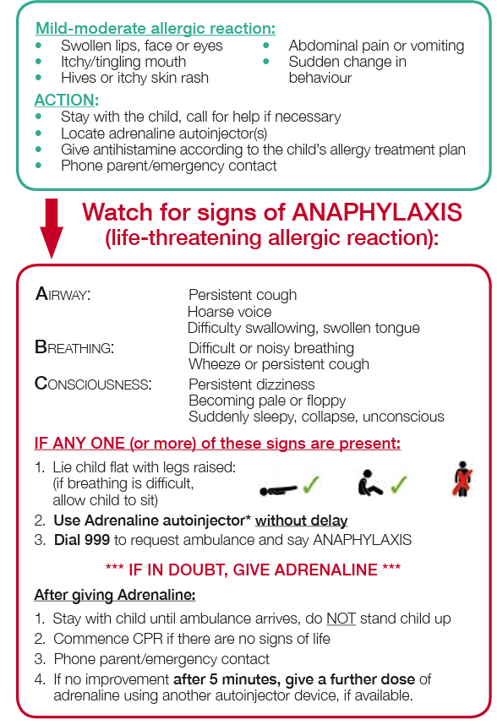
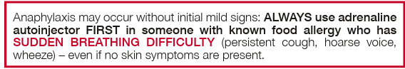

Call 999 if:
- your lips, mouth, throat or tongue suddenly become swollen
- you're breathing very fast or struggling to breathe (you may become very wheezy or feel like you're choking or gasping for air)
- your throat feels tight or you're struggling to swallow
- your skin, tongue or lips turn blue, grey or pale (if you have black or brown skin, this may be easier to see on the palms of your hands or soles of your feet)
- you suddenly become very confused, drowsy or dizzy
- someone faints and cannot be woken up
- a child is limp, floppy or not responding like they normally do (their head may fall to the side, backwards or forwards, or they may find it difficult to lift their head or focus on your face)
- You or the person who's unwell may also have a rash that's swollen, raised or itchy.
- These can be signs of a serious allergic reaction and may need immediate treatment in hospital.

Practical points:

• When dialing 999, give clear and precise directions to the emergency operator, including the postcode of your location.

• If the pupil’s condition deteriorates and a second dose adrenaline is administered after making the initial 999 call, make a second call to the emergency services to confirm that an ambulance has been dispatched.

• Send someone outside to direct the ambulance paramedics when they arrive.

• Tell the paramedics: – if the child is known to have an allergy; – what might have caused this reaction e.g. recent food; – the time the AAI was given.

The guidance in this document has been developed in conjunction with representatives of the following organisations:

• British Society for Allergy & Clinical Immunology (Paediatric Allergy Group)

• British Paediatric Allergy, Immunity and Infection Group

• Royal College of Paediatrics and Child Health

• Allergy UK

• Anaphylaxis Campaign.

The Department of Health would like to thank Dr. Paul J. Turner for his work on this guidance.

How to use an inkjet AAI. (Ones we have in school)

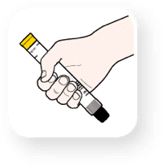Step 1 Grasp the Jext® in your dominant hand (the one you use to write with) with your thumb closest to the yellow cap.
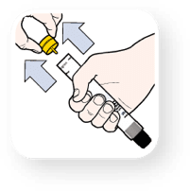Step 2 Pull off the yellow cap with your other hand.
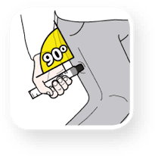Step 3 Place the black injector tip against your outer thigh, holding the injector at a right angle (approx. 90°) to the thigh.
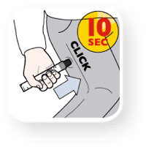Step 4 Push the black tip firmly into your outer thigh until you hear a ‘click’ confirming the injection has started, then keep it pushed in. Hold the injector firmly in place against the thigh for 10 seconds (a slow count to 10) then remove. The black tip will extend automatically and hide the needle.
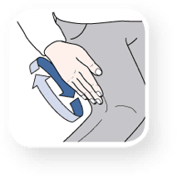Step 5 Massage the injection area for 10 seconds. Seek immediate medical help.

- A school AAI device will be used instead of the pupil’s own AAI device if:
  - Medical authorisation and written parental consent have been provided, or
  - The pupil’s own prescribed AAI(s) are not immediately available (for example, because they are broken, out-of-date, have misfired or been wrongly administered)
- If a pupil needs to be taken to hospital, staff will stay with the pupil until the parent/carer arrives, or accompany the pupil to hospital by ambulance
- If the allergic reaction is mild (e.g. skin rash, itching or sneezing), the pupil will be monitored and the parents/carers informed

7. Adrenaline auto-injectors (AAIs)
7.1 Purchasing of spare AAIs
The allergy lead is responsible for buying AAIs and ensuring they are stored according to the guidance.
- Kitt Medical supplies our AAIs.
- Each school has 4 inkjet 2x Children below 30kg (Yellow) and 2x Children/adults above 30kg (Red)
- The make are inkjets

7.2 Storage (of both spare and prescribed AAIs)
The allergy lead will make sure all AAIs are:
- Stored at room temperature (in line with manufacturer’s guidelines), protected from direct sunlight and extremes of temperature
- Kept in a safe and suitably central location to which all staff have access at all times, but is out of the reach and sight of children
- Not locked away, but accessible and available for use at all times
- Not located more than 5 minutes away from where they may be needed
- Spare AAIs kept separate from any pupil’s own prescribed AAI, and clearly labelled to avoid confusion.
- Schools AAIs are stored Chislet- Barn Hoath- First Aid Locker
7.3 Maintenance (of spare AAIs)
Anthony Sanders is responsible for checking monthly that:
- The AAIs are present and in date
- Replacement AAIs are obtained when the expiry date is near
7.4 Disposal
AAIs can only be used once. Once a AAI has been used, it will be disposed of in line with the manufacturer's instructions.
7.5 Use of AAIs off school premises
- Pupils at risk of anaphylaxis who are able to administer their own AAIs should carry their own AAI with them on school trips and off-site events
7.6 Emergency anaphylaxis kit
The school holds an emergency anaphylaxis kit. This includes:
- Spare AAIs
- Instructions for the use of AAIs
- Instructions on storage
- Manufacturer’s information
- A checklist of injectors, identified by batch number and expiry date with monthly checks recorded
- A list of pupils to whom the AAI can be administered
- A record of when AAIs have been administered

8. Training
The school is committed to training all staff in allergy response. This includes:
- How to reduce and prevent the risk of allergic reactions
- How to spot the signs of allergic reactions (including anaphylaxis)
- The importance of acting quickly in the case of anaphylaxis
- Where AAIs are kept on the school site, and how to access them
- How to administer AAIs
- The wellbeing and inclusion implications of allergies
- Training carried out annually by the allergy lead.

9. Links to other policies
This policy links to the following policies and procedures:
- Health and safety policy
- Supporting pupils with medical conditions policy

